1

Disparity for Stereo Vision

Project illustrated by Thomas Bong

CSE473 Image Processing

Project Submitted Date : December 16th, Friday 2016

2
Disparity for Stereo Vision project consisted of two main components; 1) Block matching for disparity 2) Dynamic Programming to construct a disparity map. Both components’ purpose was to extract the depth information of real objects within the given images that were taken from two different angles, left and right. Disparity consists of the information about depth(displacement) of the images by comparing the distance of a specific pixel from image 1 to the same pixel in image 2. Block matching for constructing disparity map is done by setting a block size either 3 by 3 or 9 by 9 and search for the same pixel values by calculating the SSD(Sum of Squared Differences) of the two blocks within a fixed-size search distance. Dynamic Programming is similar to calculating the longest common subsequence of the pixels within a fixed-size search distance. More detailed explanation on the methods will be thoroughly presented later. The concepts that were covered in class include stereo imaging with base line, disparity and multi-camera imaging. Multi-camera imaging is not specifically mentioned in the project description, but the 2 given images are the examples of multi-camera imaging. The two images were taken from 2 different angles, giving more information about the displacement of objects within the image. The main purpose of the project was to construct disparity maps by using the block matching algorithm with a variety of block sizes or with dynamic programming.
As mentioned above, block matching with 3x3 and 9x9 was first calculated as it was simpler than the dynamic programming approach. Block with 3x3 was first complete by setting a block of 3 pixels by 3 pixels from the left image. Then, for a search distance of 30-50 pixels to the right, a new block from the right image was compared to the block of pixels from the left image. Then for each iteration, the two blocks were compared by calculating the SSD. Each pixel value from the same index from the left block and right block was ‘squared and then subtracted’. Then, the ‘squared then subtracted’ values were all added up. This represents the SSD value for the two blocks and the lower the SSD, the similar they are. For this project, SSD less than 100 was appended to the disparity image.
Similarly, 9x9 block matching was done by setting a block of 9x9 pixels from the left image. Then the block is compared to the block of pixels from the right image for a fixed-size search distance ranging from 30-50 pixels. The range of search distance affects the results because if the search distance is too short, then you may not be reaching the same pixel. If the search distance is too long, it would not be the optimal solution to the problem in terms of time, because you may have already passed the specific pixel that you were looking for, then the program may be slightly wasting time doing unnecessary calculations. Same as 3x3, SSD value less than 100 was appended to the disparity image.
To implement the program for this project, I’ve used Python. On Python, there were a few libraries that improved the quality of the process of the project. The main libraries that were used for this project were Numpy and OpenCV. Numpy arrays were used to represent the images in arrays of pixels and OpenCV’s functions such as imread() and imshow() were used in order to load/display the images. Other than the two libraries, ‘math’ was used for calculating the SSD(involving calculations with exponents). Block Matching algorithm was done manually and also, dynamic programming was done manually. However, there were a few references that guided implementing the dynamic programming algorithm. All references are listed in the reference list section of the paper.
The results of the block matching are as follows;
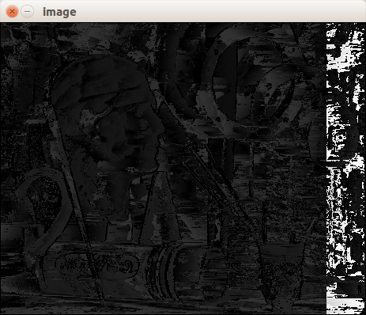

block matching 3x3 disparity map
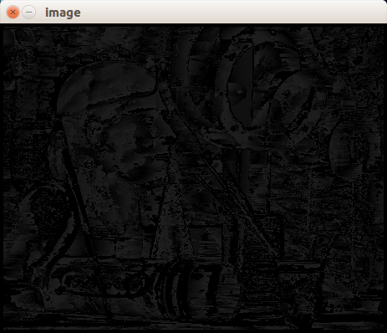

block matching 9x9 disparity map
Compared to the given disparity images, the above results differ in image display. Block matching 3x3 and 9x9 both take about 1-2 minutes.
Dynamic Programming result is as follows;
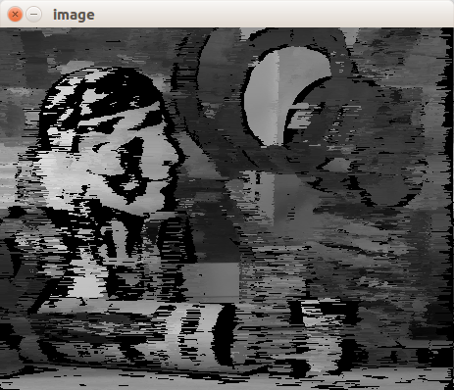

Dynamic Programming Disparity Map

All three images differ from the given disparity images. The problem for block matching is still unsolved. The implementation of block matching and SSD calculations both seem correct but the block matching algorithm is not returning the correct disparity images.

